Aim: Representation of a document with their keywords using TextRank
IDE: Google Colab

Theory:
TextRank is an algorithm based on PageRank, which often used in keyword extraction and text summarization. In this article, I will help you understand how TextRank works with a keyword extraction example and show the implementation by Python.
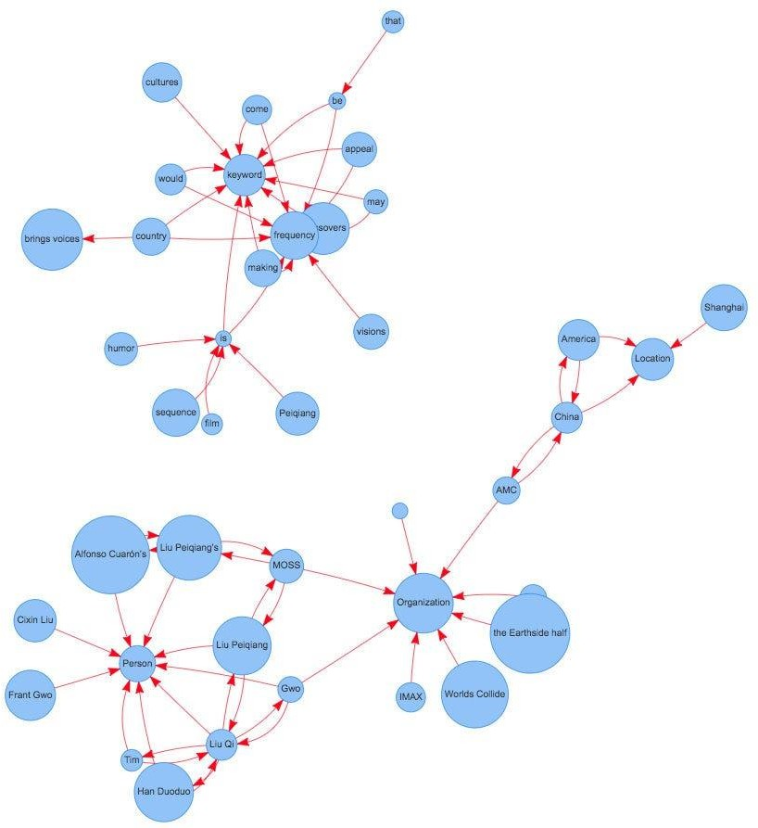
Understand PageRank

There are tons of articles talking about PageRank, so I just give a brief introduction to PageRank. This will help us understand TextRank later because it is based on PageRank. PageRank (PR) is an algorithm used to calculate the weight for web pages. We can take all web pages as a big directed graph. In this graph, a node is a webpage. If webpage A has the link to web page B, it can be represented as a directed edge from A to B. After we construct the whole graph, we can assign weights for web pages by the following formula.

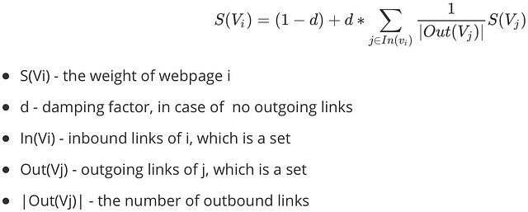
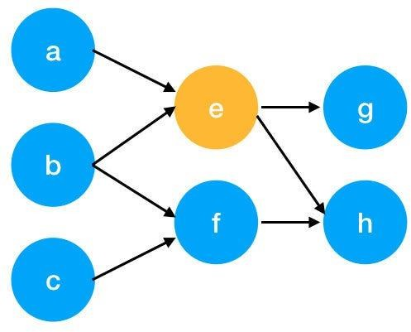

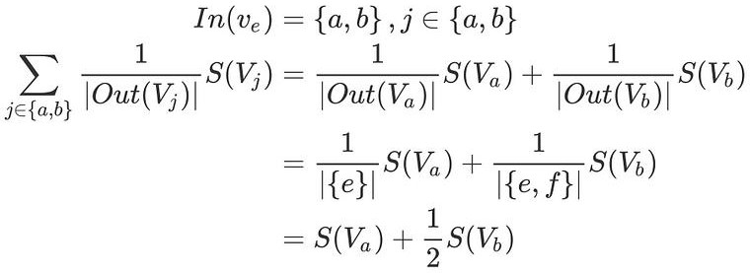
Here is an example to better understand the notation above. We have a graph to represent how web pages link to each other. Each node represents a webpage, and the arrows represent edges. We want to get the weight of webpage e. We can rewrite the summation part in the above function to a simpler version.
We can get the weight of webpage e by the following function.

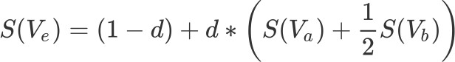

We can see the weight of the webpage e is dependent on the weights of its inbound pages. We need to run this iteration much time to get the final weight. In the initialization, the importance of each webpage is 1.

Pre Lab Exercise:
- What are the key components of TextRank?
- TextRank is based on graph and PageRank algorithm.
- Words are treated as nodes in a graph.
- Edges are created based on co-occurrence of words.
- Ranking is done using PageRank algorithm.

- What are some limitations of TextRank for keyword extraction?
- It does not understand the meaning of words.
- It depends only on word frequency and position.
- It may extract irrelevant or less important keywords.

- What are the advantages of TextRank for keyword extraction?
- It is simple and unsupervised.
- No need of training data.
- Works well for keyword extraction and summarization.

Program (Code):
import nltk
import networkx as nx
from nltk.corpus import stopwords
from nltk.tokenize import word_tokenize
import string

nltk.download('punkt')
nltk.download('stopwords')
nltk.download('punkt_tab')

def textrank_keywords(text, window_size=4, top_n=5):
words = word_tokenize(text.lower())
stop_words = set(stopwords.words('english'))
words = [w for w in words if w not in stop_words and w not in string.punctuation]
graph = nx.Graph()
for i, word in enumerate(words):
for j in range(i+1, i+window_size):
if j < len(words):
graph.add_edge(word, words[j])
scores = nx.pagerank(graph)
ranked_words = sorted(scores.items(), key=lambda x: x[1], reverse=True)
keywords = [word for word, score in ranked_words[:top_n]]
return keywords

text = """
Machine learning is a field of artificial intelligence that uses statistical techniques
to give computer systems the ability to learn from data without being explicitly programmed.
"""

keywords = textrank_keywords(text)

print("Extracted Keywords:", keywords)

Observation:

TextRank extracts important keywords from the text. It ranks words based on their importance in the graph.
Keywords represent the main idea of the document. The result depends on the input text and preprocessing.

Post Lab Exercise:
- Write about “your ownself” (in not more than 500 words→ You know better about you, rather than ChatGPT!!). Extract top-25 keywords for your portfolio and analyze it in 3 categories: keyword can not give the real idea, keyword gives the real idea, keyword is irrelevant. Paste the code, your portfolio, output and your analysis.
import nltk
import networkx as nx
from nltk.corpus import stopwords
from nltk.tokenize import word_tokenize
import string
nltk.download('punkt')
nltk.download('stopwords')
nltk.download('punkt_tab')
def textrank_keywords(text, window_size=4, top_n=25):

words = word_tokenize(text.lower())

stop_words = set(stopwords.words('english'))
words = [w for w in words if w not in stop_words and w not in string.punctuation]

graph = nx.Graph()

for i, word in enumerate(words):
for j in range(i+1, i+window_size):
if j < len(words):
graph.add_edge(word, words[j])

scores = nx.pagerank(graph)

ranked_words = sorted(scores.items(), key=lambda x: x[1], reverse=True)

keywords = [word for word, score in ranked_words[:top_n]]

return keywords
text = """
My name is isha savaliya. I am currently studying at marwadi university. I am a student of Information and communication Technology with interest in Artificial Intelligence and Machine Learning.
I like learning new technologies and improving my programming skills.I have knowledge of Python, Java and web development.I enjoy solving problems and working on real-world projects.
I am also interested in app development and backend systems.My goal is to become a skilled software developer.I have worked on various projects including web applications using Laravel
and mobile applications using Android Jetpack Compose. I like building user-friendly and efficient systems. I am also interested in backend development and API integration.
"""
keywords = textrank_keywords(text)
print("Extracted Keywords:", keywords)

Extracted Keywords: ['web', 'projects', 'like', 'backend', 'also', 'interested', 'learning', 'using', 'development', 'applications', 'currently', 'studying', 'marwadi', 'university', 'student', 'information', 'communication', 'technology', 'interest', 'artificial', 'savaliya', 'intelligence', 'programming', 'improving', 'skills.i']

